Sequoyah County Water Association
3520 W. Cherokee
PO Box 627
Sallisaw, OK 74955-0627
918-775-9672
Website: sequoyahwater.org
Email: scwa@sequoyahwater.org

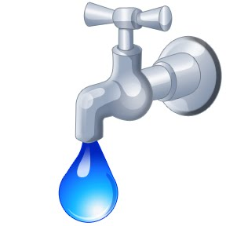

SEQUOYAH COUNTY WATER ASSOCIATION
AUTHORIZATION AGREEMENT FOR ELECTRONIC PAYMENT PLAN

Phone No: _____________________ SCWA Acct No:_____________________
Name on SCWA bill ____________________________________________________________

I authorize Sequoyah County Water Association (SCWA) to begin monthly deductions for payment of my water bill and for the financial named to pay each amount from my checking account for the date shown on my bill. I understand that I may cancel this authorization by notifying SCWA to remove my account from the Electronic Payment Plan and that SCWA will have thirty (30) days to change my billing. I understand that SCWA reserves the right to terminate my participation in the Electronic Payment Plan. (Payments will come out of your account the 7th of every month)

Date_________________________ Applicant________________________________

Note: To ensure proper bank coding, attach a VOIDED blank check. Please allow 4-6 weeks for implementation of auto bank draft.
**Any charges previously waived as a courtesy of SCWA by starting bank draft, will be applied to your SCWA account if your bank draft is returned for NSF or stopped by customer**

This institution is an equal opportunity provider and employer.

