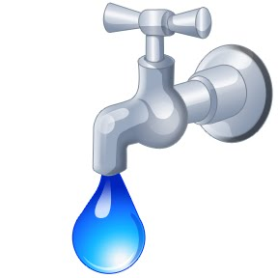

**SEQUOYAH COUNTY WATER ASSOCIATION**

**ELECTRONIC PAYMENT CANCELLATION FORM**

SCWA Acct#________________

Phone #___________________

Customer Name on Acct____________________________

I wish to cancel my monthly deductions for payments of my water bill that is deducted from my checking account each month. No further water bills will be taken out of my checking account as of the date listed by me on this form.

Date________________________

Signature_____________________________

Printed Name__________________________

Sequoyah County Water Association

3520 W. Cherokee

PO Box 627

Sallisaw, OK 74955-0627

918-775-9672

Website: sequoyahwater.org

Email: [scwa@sequoyahwater.org](mailto:scwa@sequoyahwater.org)