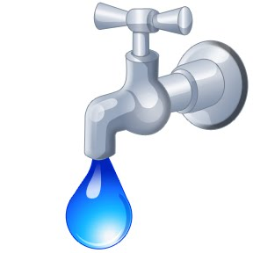
Sequoyah County Water Association
3520 W. Cherokee
PO Box 627
Sallisaw, OK 74955-0627
918-775-9672
Website: sequoyahwater.org
Email: scwa@sequoyahwater.org

Account_______________ (For office use only)

I, present owner (print name)____________________________________________________________
the owner of SEQUOYAH COUNTY WATER ASSOCIATION, SEQUOYAH COUNTY OKLAHOMA, Hereby assign, convey, and transfer the said Certificate to:

_____________________________________________________________________________________
(Print or type new owner (s) name (s))

_____________________________ _
Effective Signature Present Owner
Date of transfer__________________________
___________________________________________
Meter#_________________________________ Mailing Address

Final Reading___________________________ ___________________________________________

Disconnect if new owner does not transfer service or Accept Assignment ___________________________

ACCEPTANCE OF ASSIGNMENT

___________________________________________,(new owner) the assignee named in the above Assignment, hereby accept the Assignment to (him, her), of the above described Certificate and agree to assume and be bound by all of the obligations imposed upon the holder of such Certificate by the By-Laws and the Rules and Regulations of Sequoyah County Water Association, Sequoyah County, Oklahoma
____________________________________
Signature- New Owner (s)

_______________________________________ ___________________________________________
Physical or 911 address of property Mailing address

_______________________________________ ___________________________________________

**when you provide your phone number we Phone No.__________________________________
automatically sign you up for alerts**

